Abbots Morton Village Hall
Autumn Newsletter
September 2024

Christmas Fayre Returns
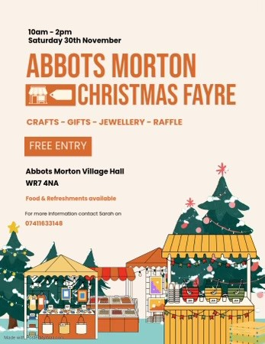
Great news! There will be a Christmas Fayre at the village hall for the first time since 2019…just before the Covid 19 pandemic struck.
It will be on Saturday November 30th from 10am to 2pm. Entry is free.
A wide variety of seasonal products will be for sale. Teas, coffees and mince pies will be on sale and there’ll be a great raffle. All proceeds will go to Abbots Morton village hall funds. Do save the date in your diary and let your friends and family know about it. See you there!

Jacki joins the Village Hall Committee
We’re delighted to welcome Jacki Allum to the Village Hall Committee. Jacki, who lives in the village, has taken over from Martin Willingale as a representative of the Parish Council where she has been a Parish Councillor for a year. Together with her husband Stephen, Jacki is a regular user of the village hall at Community Coffee Mornings and at our Wednesday morning Tai Chi classes. Jacki is already an invaluable member of the committee.
May we take this opportunity to hugely thank Martin Willingale for his years of service on the Committee. Martin remains a “Friend of the Village Hall” and still helps out in all sorts of ways!

-2-
The Trustees

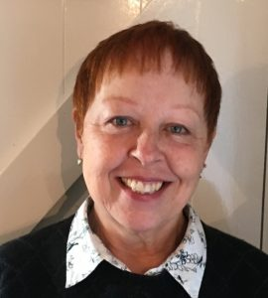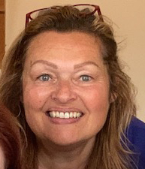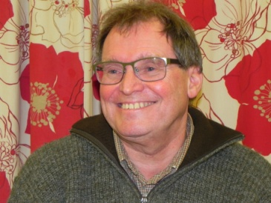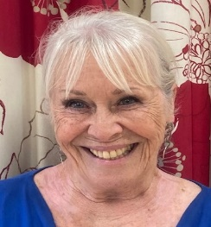
Lynne Pemberton Pat Willingale Sarah Dykes Colin Pemberton Jacki Allum
Chair Secretary Treasurer Bookings Officer Parish Council
07900 246413 07484 104967 07411 633 148 07766 524833 Representative

Our Treasurer Sarah Dykes has sold her house in the village and now lives in Clifton upon Teme. We’re pleased that Sarah remains a member of the village hall management committee, continuing as Treasurer, which she is able to do by electronic banking and the wonders of modern communications. But it means there’s one less committee member to do some of the unsung jobs around the hall and grounds that need doing to make everything run smoothly and be well maintained.
If you would like to become involved in running our beautiful and valuable community space, please contact any of the current team (above). It's enjoyable, not arduous and very rewarding to be custodians of the valuable asset that is our village hall.

Tai Chi
Tai Chi classes resumed at the hall on September 4th for the Autumn Term. They’ve been very successful since they began in February. The hour-long classes between 10 and 11am on Wednesday mornings are run by Andrew Lowe from Inkberrow. Around eight people attend on a regular basis and Andrew says he can accommodate more if you wish to join in. Simply call or text him on 07495 206178. If you block book for six weeks, the cost is £10 a session or £11 a session if paid individually.

Community Coffee Morning
And still on wellbeing… how enjoyable are the coffee mornings at the hall on the First Tuesday of every month! It’s a lovely and easy way to get out for a while and meet other people in a relaxed atmosphere. Around 18 people from the village, the hamlets, the wider neighbourhood and even from around Church Lench meet together to enjoy a chat and a catch-up over a cup of coffee or tea, with biscuits and (more often than not) cake of some description. It’s free. There is no charge for entry or for any of the beverages or confections, although many do choose to make a contribution towards the cost of electricity or donate a jar of coffee/pack of tea bags or bring along a home-baked cake. If you haven’t been yet, do come along. They start at 10am and run through to 12 noon and you can drop in and stay as long or as little as you wish. The next coffee morning will be on Tuesday 1st October.

-3-

DID YOU KNOW this about the village hall?
- The village hall is a Charity (Charity no 201544) registered with the Charity Commission.
- It was built in 1998 {The original hall was established in 1921}.
- It costs around £5,000 a year to run… we’re just about breaking even.
- It is separate from the church and the parish council and doesn’t get money from council tax payers.
- There is a Hire Fee discount for local people.
- It has its own webpage on the parish council website (www.abbotsmorton.info/abbots-morton-village-hall
- It has its own Facebook page: Abbots Morton Village Hall
- Its run by volunteers... The Trustees …and we need more! Would you like to help run our lovely hall?
- You can raise money for the village hall by becoming an EasyFundraiser. If you shop online you’ll find that most retailers will donate a small portion of your spend to the village hall ...once you’ve registered with EasyFundraising and nominated Abbots Morton Village Hall as your ‘good cause’ to support. We currently have 26 EasyFundraisers who, between them, have now raised £1,305.81 since we started in 2015. If you want to be our 27th EasyFundraiser go to : https://www.easyfundraising.org.uk/causes/abbotsmortonvillagehall/?invite=1UE2GE%26referral-campaign=c2s%26utm_campaign=admin-trigger%26utm_content=srt
Bookings
Our hall is an ideal venue for your birthday party, your children’s birthday parties, wedding receptions, funeral wakes and many other events.
If you would like to hire the hall, call our Bookings Officer, Colin, on 07766 524833. Our rates are:
HALL HIRE FEES

Local Non local
Summer: (1st June to 31st Aug) £11.50 per hour £13.00 per hour
Winter: (1st Sept to 31st May) £13.50 £15.00
Wedding Package (exclusive use of the hall, including the full use of kitchen appliances, from 5pm Friday to 12pm Sunday)
Summer £450 £500
Winter £540 £600
Best wishes from the Village Hall Committee
- Colin Pemberton, PRO. September 2024

